Task 3.2

1. Show the process activity in real time with “top” or “ps –A” for all processes

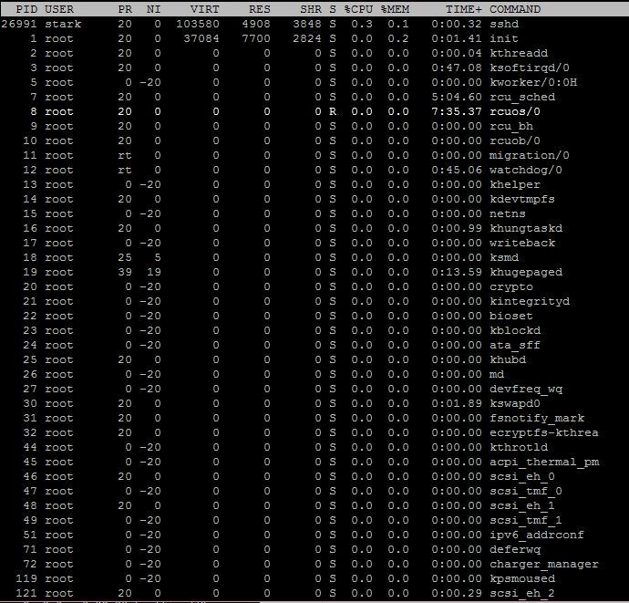

1. Show all running or stopped services with “service --status-all”

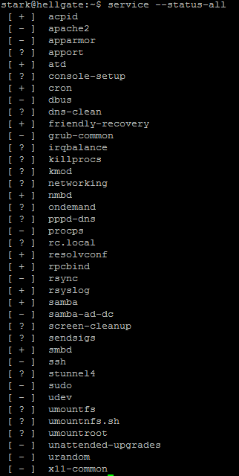

1. Finding out the operating system with “cat /etc/\*-release

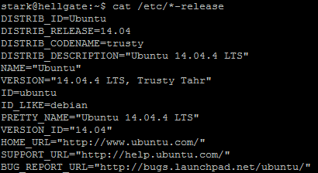

1. Finding out the openSSL version with “dpkg -l openssl”

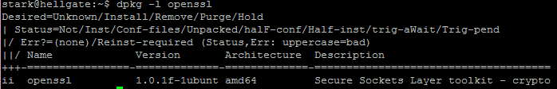

1. Finding out the ip addresses with “/sbin/ifconfig”

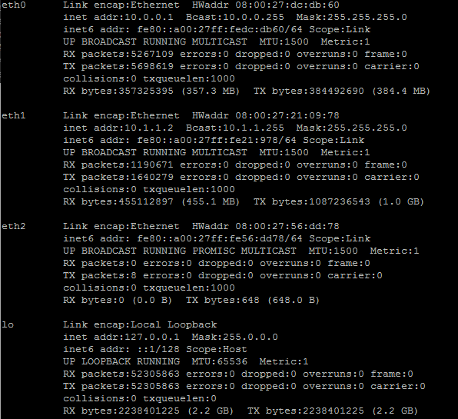

1. Show all TCP ports with nmap using “nmap -sT 10.0.0.1”

